# CREATE A SCREENSHOT

1. For PC users:

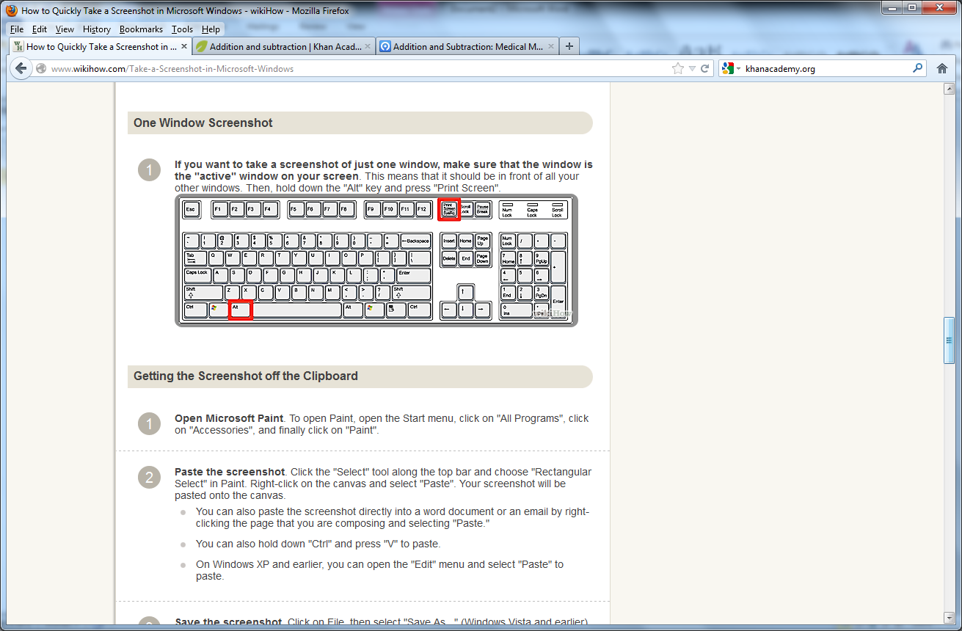

Hold down the ALT button and press the Print Screen Button –highlighted in red in the image above. Open a Word document and paste the image into your document. Save the document. It can be uploaded as a file into your Canvas Assignment.

1. For Mac Users:

Press Command + Control + Shift + 4. This method will put the image onto your clipboard. Open a Word document and past the image where desired. Save your document.

Pressing Command + Shift + 4 will save the image to your desktop

